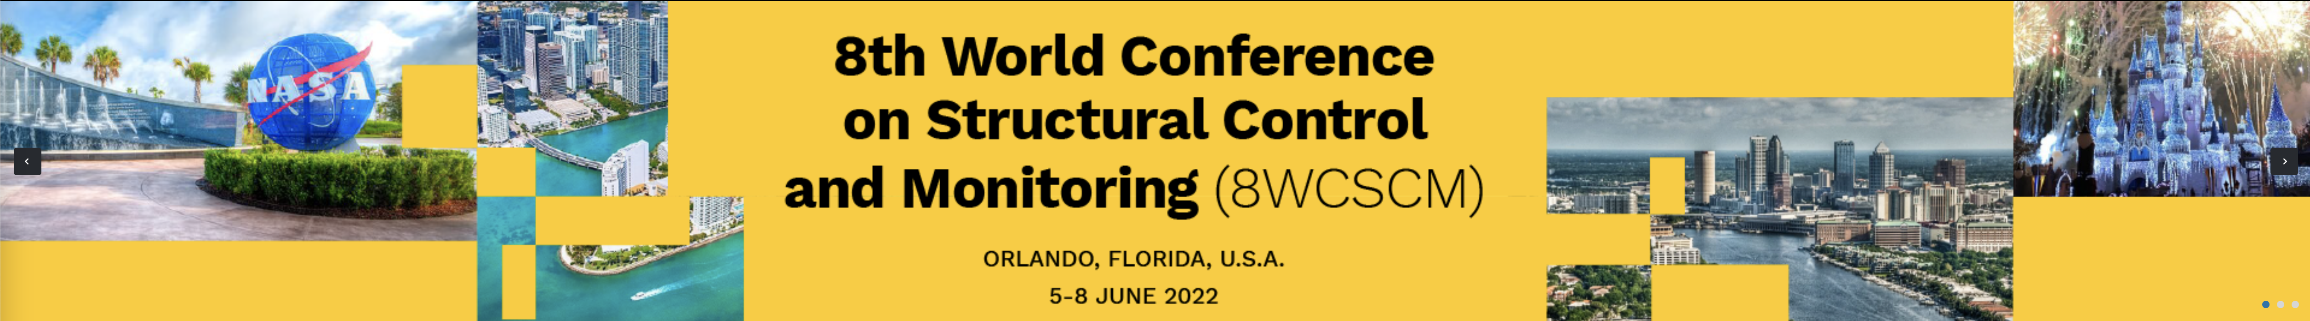
Call for 8WCSCM Special Session Proposals
The 8th World Conference on Structural Control and Health Monitoring (8WCSCM) is seeking proposals for special sessions within a general scope of the conference. Special sessions are expected to cover the state-of-the-art and emerging research in structural control and monitoring (SCM). We also encourage special sessions with a focus on the SCM applications in the development of smart cities technologies. Proposals will be evaluated based on the quality of the proposal, potential impacts on SCM community, and timeliness. Special session submissions at 8WCSCM will be peer-reviewed in the same way as submission to regular sessions.
Proposers should include the following information in their submission:
1. Special session title
2. Names of proposer(s)
3. Titles, affiliations, and contact information of proposer(s)
4. Description of the proposed session (1-2 paragraphs)
5. List of the proposed topics

SUBMISSION
Proposal submission (in pdf format) and inquiries related to special sessions should be sent via email to special session chairs at specialsession@8wcscm.org.

8WCSCM Special Session Proposal
- Organizer Information (Names, Titles, Affiliations, and Emails)
  - __________________________________________________________________
  - __________________________________________________________________
  - __________________________________________________________________
- Session Information
  - Tentative special session title: _________________________________________
__________________________________________________________________
  - Description of the proposed session (1-2 paragraphs): ____________________________________________________________________________________________________________________________________________________________________________________________________________________________________________________________________________________________________________________________________________________________________________________________________________
  - List of the proposed topics
    - ____________________________________________________________
    - ____________________________________________________________
    - ____________________________________________________________
    - ____________________________________________________________
    - ____________________________________________________________
*** SUBMISSION: Proposal submission (in pdf format) and inquiries related to special sessions should be sent via email to special session chairs at specialsession@8wcscm.org. ***

